**Jig Order Monitoring System**

**Work Instruction**

**TABLE OF CONTENTS**

**JIG ORDER MONITORING PROCESS FLOW** **4**

**MPPD1 / REQUEST INTERFACE**  **5**

1. **LOGIN**
2. **IMPORT REQUEST DATA**
3. **REQUEST MONITORING**
4. **CANCELLATION REQUEST**
5. **ACCOUNT MANAGEMENT**
6. **LOGOUT**

**AME3 / PURCHASING INTERFACE** **11**

1. **LOGIN**
2. **REQUEST DATA**
3. **SET RFQ + PO PROCESS**
4. **EXPORTING REQUEST**
5. **IMPORTING REQUEST**
6. **CANCELLATION REQUEST**
7. **CLOSED REQUEST HISTORY**
8. **ACCOUNT MANAGEMENT**
9. **LOGOUT**

**AME2 / INSTALLATION INTERFACE** **15**

1. **LOGIN**
2. **DEDUCTION APPROVAL**
3. **UPDATE MASTER MAINTENANCE**
4. **UPDATE MANAGE ACCOUNT**

**USER ACCOUNT** **21**

1. **LOGIN**
2. **DEDUCTION BUDGET**
3. **EXPORT AND PRINT DEDUCTION SUMMARY**

**PROCUREMENT ACCOUNT** **27**

1. **LOGIN**
2. **UPDATE PURCHASE ORDER NO.**
3. **CANCEL PURCHASE ORDER**

**APPROVER ACCOUNT** **32**

1. **LOGIN**
2. **CANCEL PURCHASE ORDER**

**JIG ORDER MONITORING SYSTEM**

**PROCESS FLOW**

Log in to Jig Order Monitoring System

AME1 Import pending request data

Notify AME3 for the pending request

Export pending request and import Initial RFQ, RFQ, and PO process

View the closed request data history for a specific date

AME2 install and generate request based on installation date

AME1 monitor the delayed request Data

**JIG ORDER MONITORING SYSTEM**

**Work Instruction**

(**JOMS MPPD1**: PRODUCTION ENGINEERING)

1. **LOGIN**
   1. Enter **Username and Password** *(See Figure 1.0).*
   2. Click **Sign in** Button to access Main Form *(See Figure 1.0).*

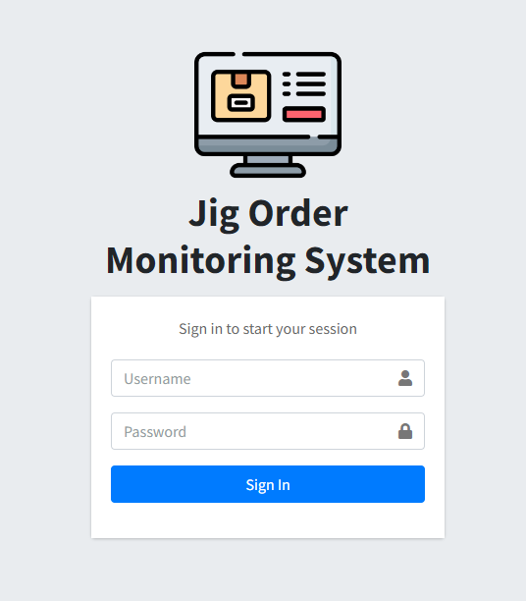

***Figure 1.0***

1. **IMPORT REQUEST DATA**

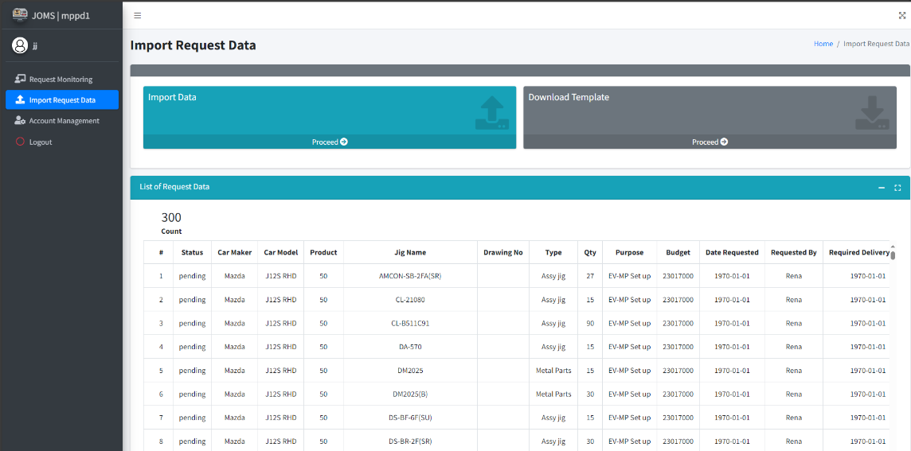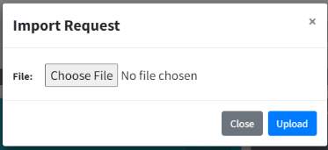

***Figure 1.1***

* 1. In the navigation bar, click **Import Request Data** (*See Figure 1.1*).
  2. Theuser can **download the template** by clicking the **Proceed** button as shown in the figure above (*See Figure 1.1*).

2.2. Open **template for request.csv** and encode the request data then **save the file**. (*See Figure 1.2*).

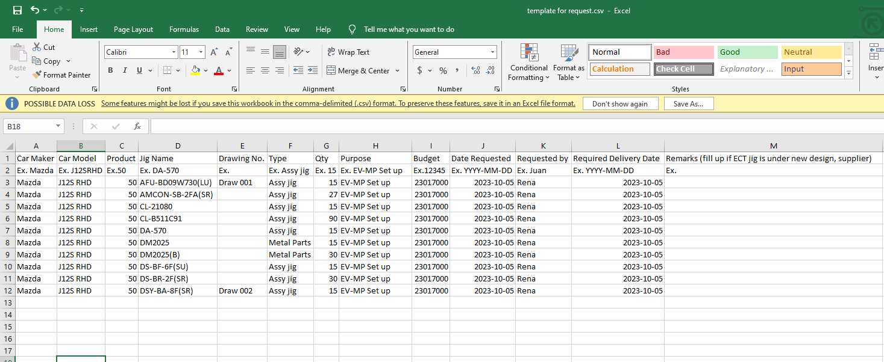

***Figure 1.2***

* 1. Click **proceed** in Import data then show the “choose file” (*See Figure 1.1*).

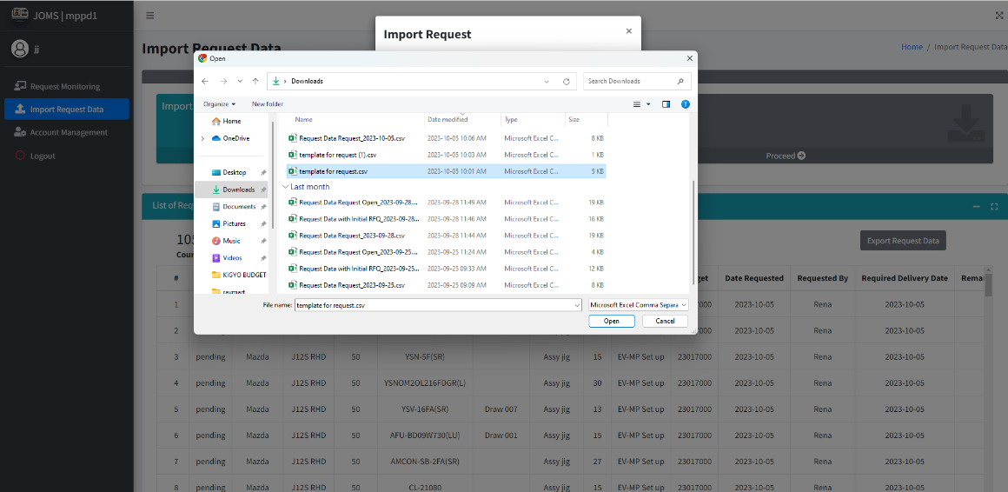

***Figure 1.3***

* 1. **Import** the data using the download template with encoded request data. Note that incorrect format will result to error (*See Figure 1.3*).

1. **REQUEST MONITORING**

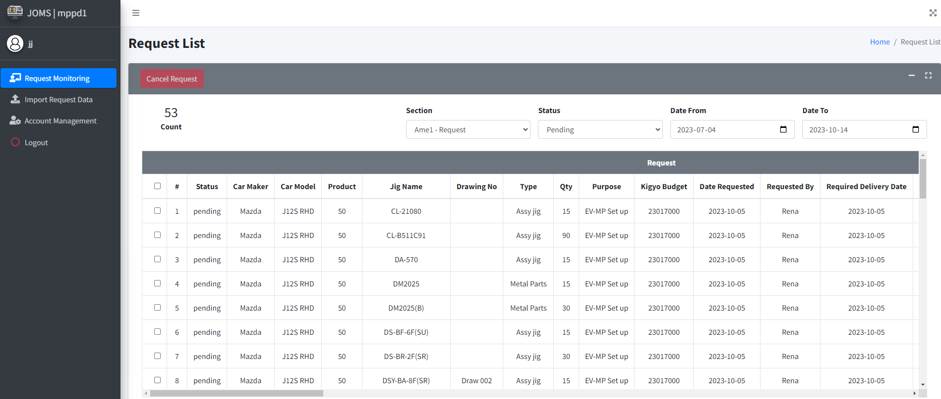

***Figure 1.4***

1. In the navigation bar, click **Request Monitoring** (*See Figure 1.4*).
2. To filter the table, click **Section, Status, Date From, Date to.** (*See Figure 1.4*).
3. Viewing the **number of rows** in the table. (*See Figure 1.4*).
4. **CANCELLATION REQUEST**

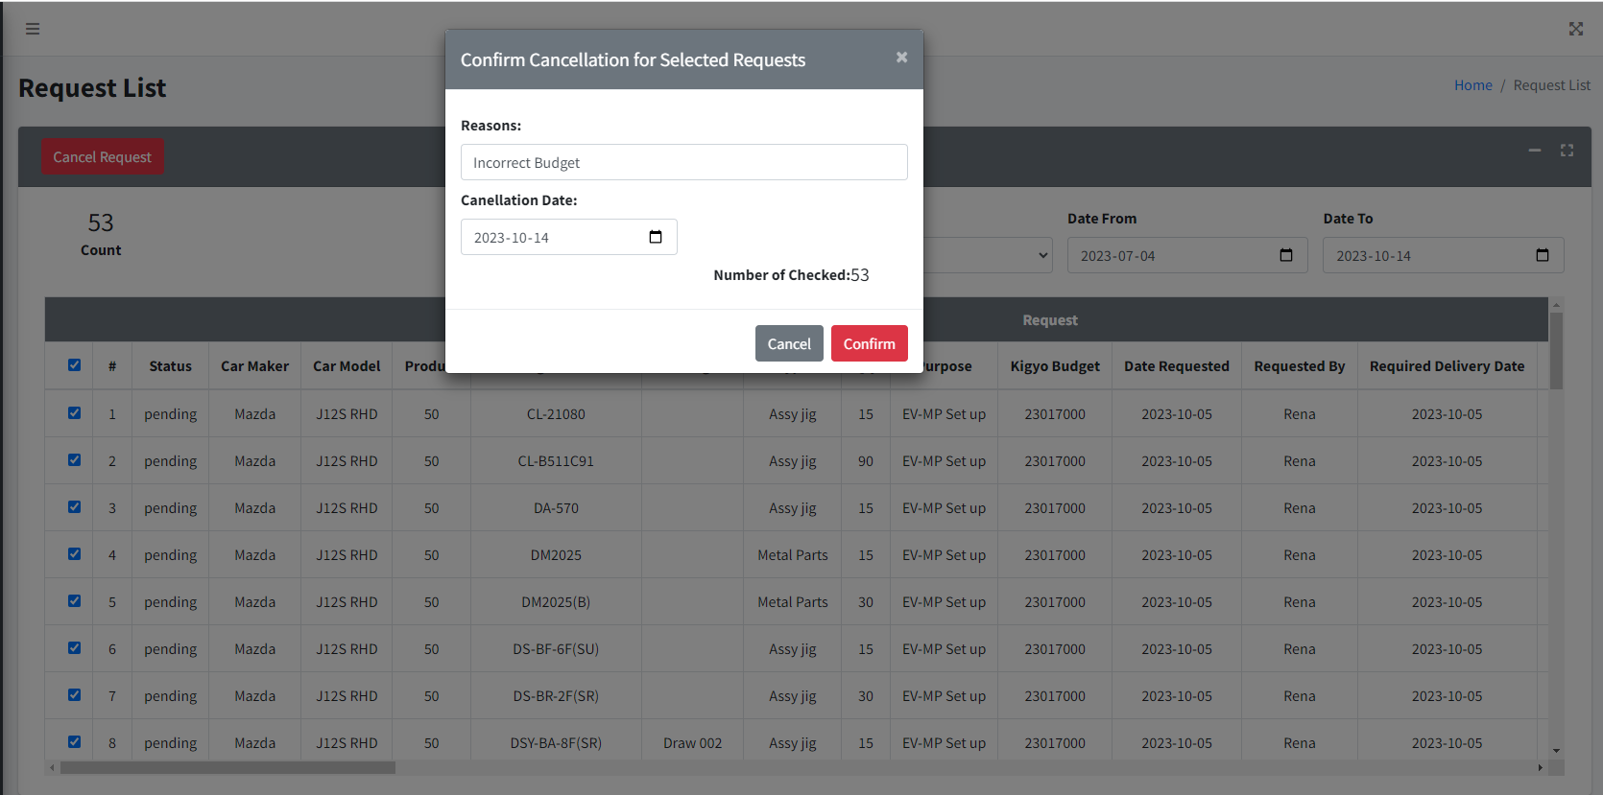

***Figure 1.5***

1. To cancel, select the **checkbox** that corresponds to the item you wish to cancel (*See Figure 1.5*).
2. Click the **Cancel Request** to pop up the **Cancellation for Selected Request.** (*See Figure 1.5*).
3. Provide an **explanation** for canceling and include the **date of cancellation,** click the **confirm** button. (*See Figure 1.5*).

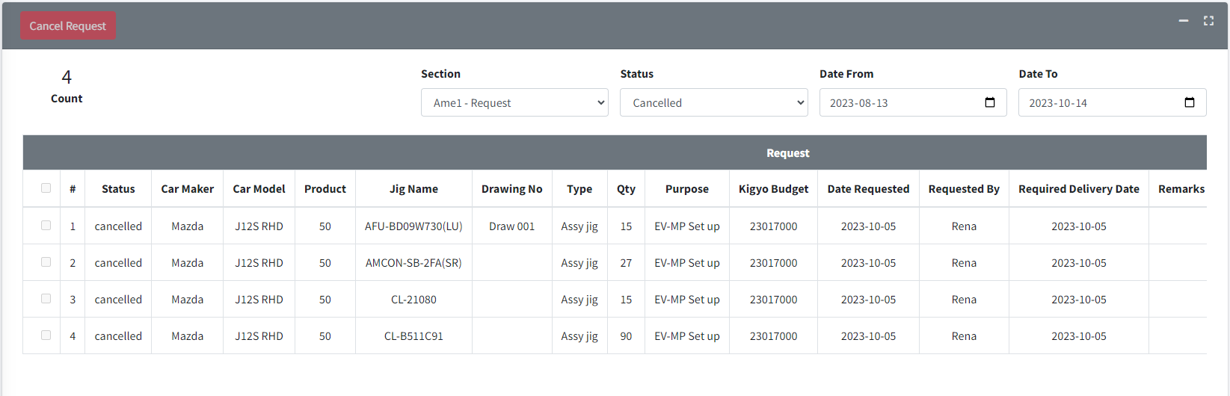

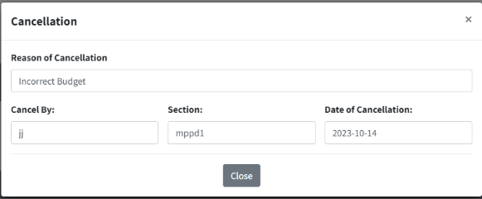

***Figure 1.6***

1. Click your **Section**, status must be **Cancelled,** and set the date from and date to. (*See Figure 1.6*).
2. Click **cancelled** under status column. (*See Figure 1.6*).
3. View the **cancellation** data. (*See Figure 1.6*).
4. **ACCOUNT MANAGEMENT**

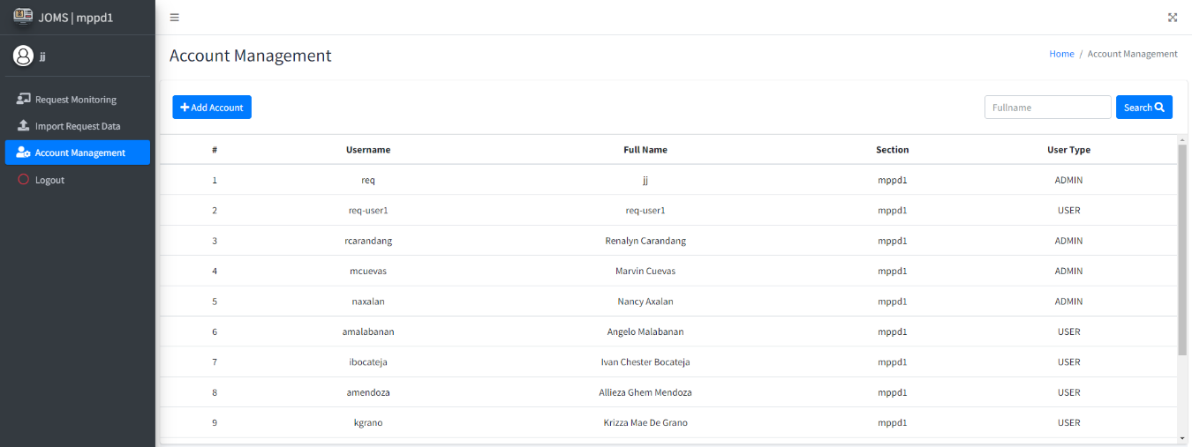

***Figure 1.7***

1. Click the **Account Management** (*See Figure 1.7*).
2. Click **Add Account** and create an account (*See Figure 1.7*).
3. **View** data table for your accounts. To Update, **Click** the data you want to **UPDATE**, or **DELETE** the account (*See Figure 1.7*).
4. **Search** accounts by full name (*See Figure 1.7*).
5. **LOG OUT**

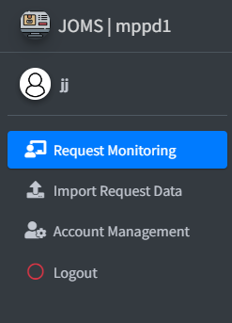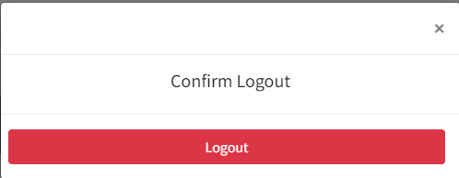

***Figure 1.8***

1. Click **log out**
2. Show msg box click confirm **Logout.** Don’t forget to log out when you’re not around or before leaving.

**JIG ORDER MONITORING SYSTEM**

**Work Instruction**

(**JOMS AME3**: PRODUCTION ENGINEERING)

1. **LOGIN**
   1. Enter **Username and Password** *(See Figure 1.0).*
   2. Click **Sign In** button to access Main Form *(See Figure 1.0).*



***Figure 2.0***

1. **REQUEST DATA**
   1. Click **Request Data** button to access Main Form *(See Figure 2.1).*
   2. Viewer of List of Request Data uploaded by **Requestor** *(See Figure 2.1).*
   3. Click **Proceed** Export Request Data to download list of request data *(See Figure 2.1).*

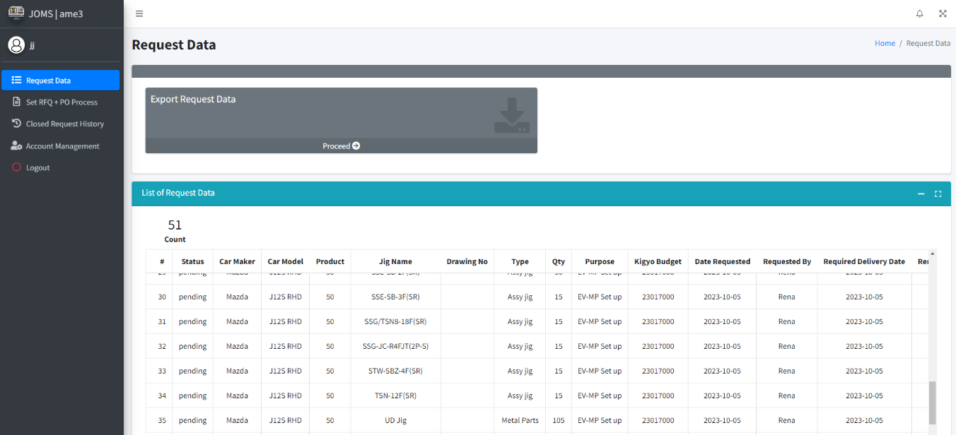

***Figure 2.1***

***Figure 2.1***

1. After export the file. You can view the data and fill-up the Initial RFQ missing data.

*(See Figure 2.2).*

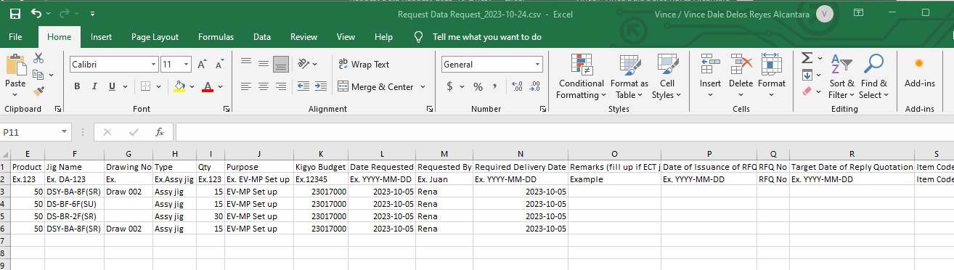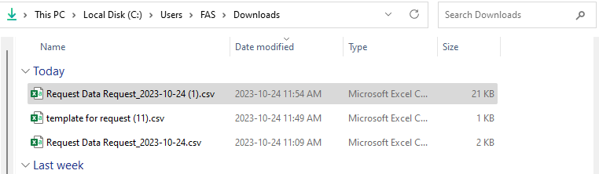

***Figure 2.2***

1. **SET RFQ AND PO PROCESS**
   1. Click **Set RFQ + PO Process** button *(See Figure 2.3).*
   2. Click **Proceed** in Export Request Data + RFQ + PO *(See Figure 2.3).*
   3. Click **Proceed** in Import Request Data + RFQ + PO *(See Figure 2.3).*
   4. Filter the table to **RFQ Process, Initial RQF, Complete RFQ and Cancelled** *(See Figure 2.3).*
   5. *Select you want to* ***Cancel*** *(See Figure 2.3).*
   6. *Click* ***Cancel Request*** *(See Figure 2.3).*

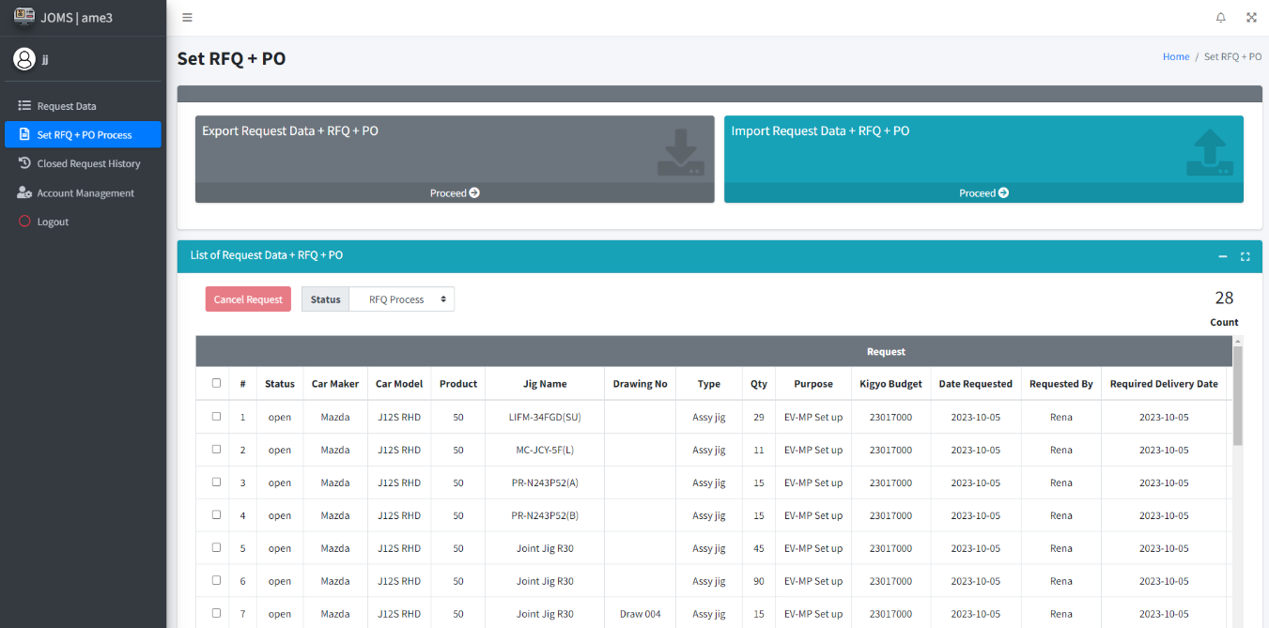

***Figure 2.3***

1. **EXPORT REQUEST DATA + RFQ + PO**
2. Click **Export Pending** to export the **Request** data. *(See Figure 2.4).*
3. Click **Export Open Status** to export with **Initial RFQ** data *(See Figure 2.3).*
4. Click **Export Open Status** to export with **Complete RFQ** data *(See Figure 2.3).*
5. Click **Export Closed Status** to export with **Complete RFQ and PO** data *(See Figure 2.3).*

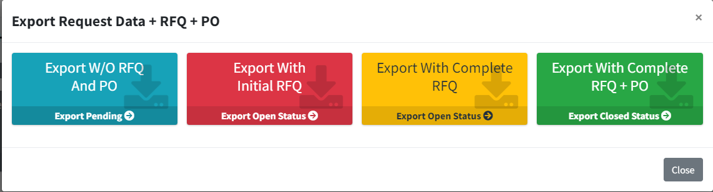

***Figure 2.4***

Once clicked export they automatically **downloaded** the file. Open the file.

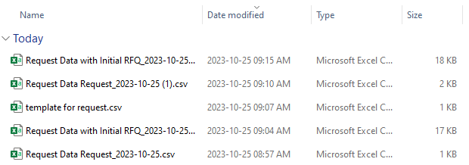

Example export data in EXPORT W/O RFQ and PO.

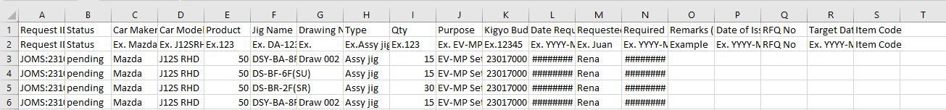

Example export data in EXPORT WITH INITIAL RFQ

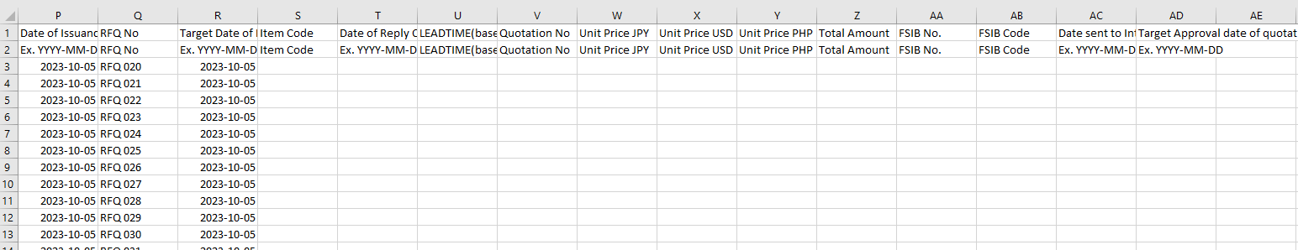

Example export data in **export with complete RFQ**.



Example export data in **Export with** **Complete RFQ and PO.**

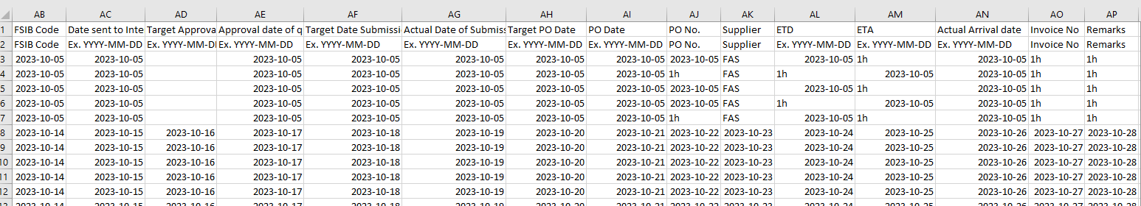

1. **IMPORT REQUEST DATA + RFQ + PO**
   1. Click **Import Initial RFQ** in Import Req + initial RFQ *(See Figure 2.5).*
   2. Click **Import RFQ** in Import Req + initial RFQ *(See Figure 2.5).*
   3. Click **Import PO** in Import Req + complete RFQ + PO *(See Figure 2.5).*

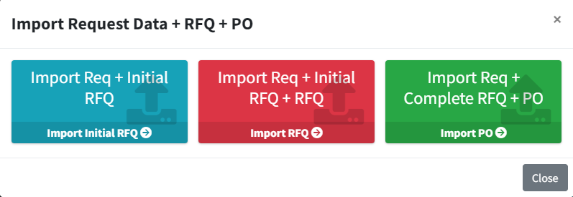

***Figure 2.5***

Once click the import, import Initial, Import RFQ, and Import PO.

Choose file you want to import the Request Data.

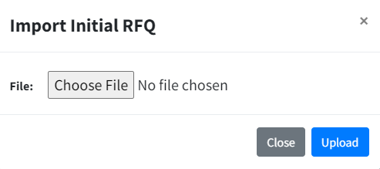

Choose file you want to import the Request Data.



1. **CANCELLATION REQUEST**

1. To cancel, **select the checkbox** that corresponds to the item you wish to cancel (See Figure 2.6)

2. Click the **Cancel Request** to pop up the Cancellation for Selected Request. (See Figure 2.6).

3. Provide an **explanation** for canceling and include the **date of cancellation**, click the confirm button. (See Figure 2.6).

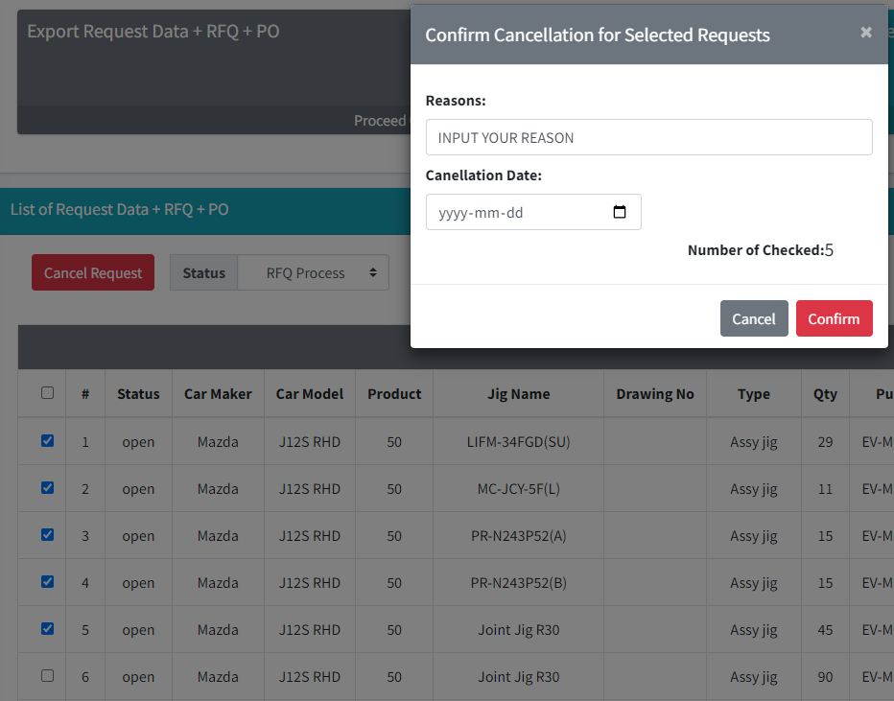

***Figure 2.6***

4. Click the **status** to filter the all **cancelled** request data(See Figure 2.7).

**5.** Click **cancelled** under status column (See Figure 2.7).

6. View the cancellation data (See Figure 2.7).

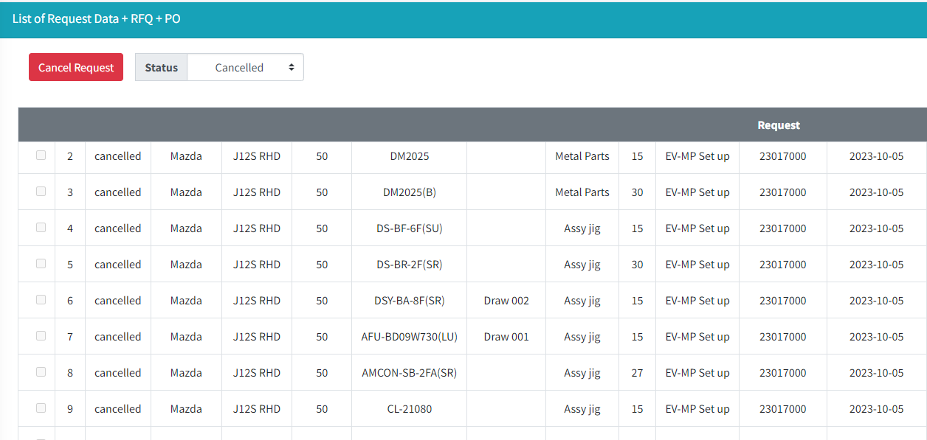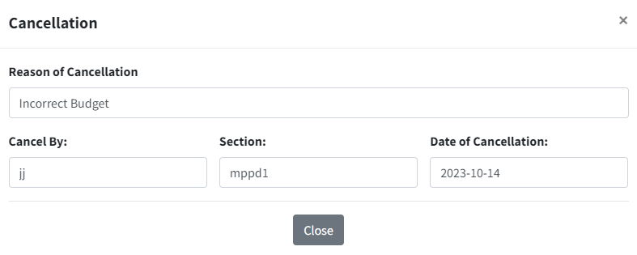

***Figure 2.7***

1. **CLOSED REQUEST HISTOR**
   1. Click **Closed Request History.**
   2. Click the **History Date from** and **History Date to**, to filter the table by specific date format and Click **Search**.
   3. Viewer of the all history **closed** data request filtered by specific date.
   4. Click **Export History** to download the Close request data.

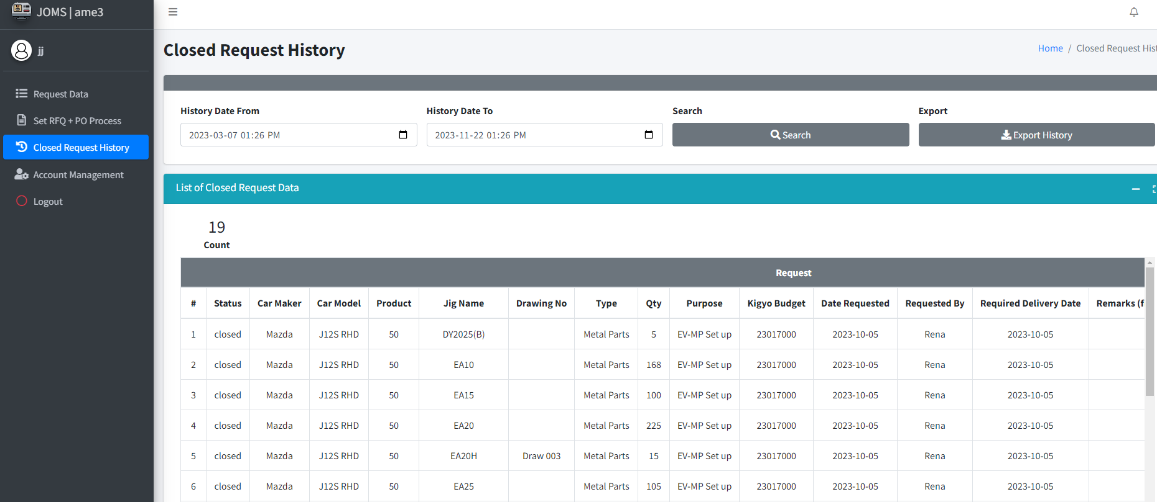

***Figure 2.8***

1. **ACCOUNT MANAGEMENT**

1. Click the Account Management (See Figure 2.9).

2. Click Add Account and create an account (See Figure 2.9).

3. View data table for your accounts. To Update, Click the data you want to UPDATE, or DELETE the account (See Figure 2.9).

4. Search accounts by full name (See Figure 2.9).



***Figure 2.9***

1. **LOGOUT**
   1. Click **log out** button. (See Figure 2.10).
   2. Show msg box click confirm **Logout**. Don’t forget to log out when you’re not around or before leaving (See Figure 2.10).



***Figure 2.10***

**JIG ORDER MONITORING SYSTEM**

**Work Instruction**

(**JOMS AME2**: PRODUCTION ENGINEERING)